Chapter 14, Solution 23.

The Bode magnitude plot of H(ω) is shown in Fig. 14.75. Find H(ω).

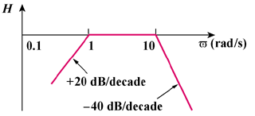
(db)

0
ω (rad/s)

Figure 14.75
For Prob. 14.23.

Solution

A zero of slope at the origin
A pole of slope at
A pole of slope at

Hence,

(It should be noted that this function could also have a minus sign out in front and still be correct. The magnitude plot does not contain this information. It can only be obtained from the phase plot.)

